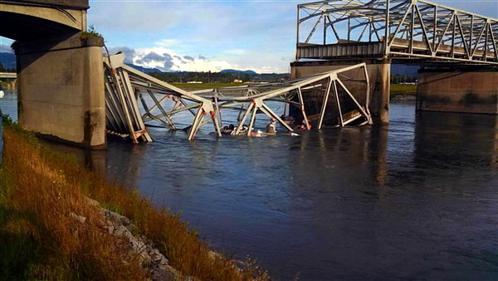

In this lab you will work on solving a set of simultaneous linear equations that represents a bridge structure consisting of a number of trusses.

**Exercise 7 – Bridge analysis.**

We will write a program that will solve a set of simultaneous equations using MATLAB. The structure you will analyse is shown below:

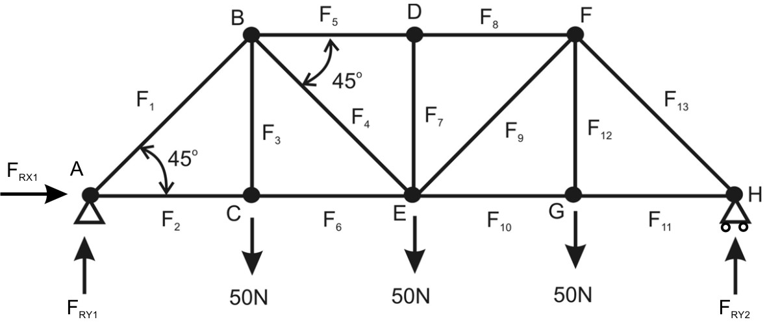

We can see we have 8 pin joints and 13 unknown truss forces and 3 reactive forces where the bridge sits. We have a loads at the joints C, E and G. We can make a few assumptions in order to evaluate the bridge. Firstly all forces are passed axially through the trusses, forces are positive when in tension so if we get a negative value for force, the member is in compression.

Secondly, it is assumed that the bridge is in equilibrium, there is no movement due to the loading. We can sum all the forces in both the horizontal and vertical directions to be equal to zero.



If we do this at each joint we can produce a set of simultaneous linear equations that can then be solved using the backslash operator \ or finding the inverse.

1. On paper, write down the equations for each pin joint, there should be two for each joint,

e.g. for joint A:

In X axis: F1cos(45) + FRX1 + F2 = 0

In Y axis: FR1 + F1sin(45) = 0

1. When we set out the equations for the loaded joints at C, E and G for the Y axis we place the loads on the right hand side of the equations. We should end up with 16 equations, two for each joint.
2. We need to place the equations in matrix form Ax=b where x is a 16x1 column vector containing the unknown forces. b is a 16x1 column vector containing the inputs. Matrix A will be a 16 x 16 matrix consisting mainly of zeros containing the coefficients of the forces.

We can start with the first equation in row 1:

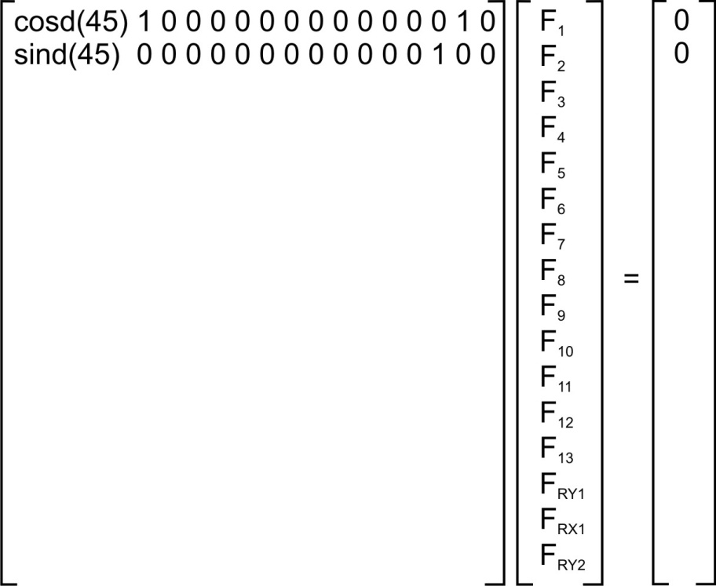

1. Once we have created our matrix on paper we can now place it into code. Open a new script and save it as bridge_solver.m. Add comments to the first line of your code explaining what your code is going to do. To simplify entering the matrix into MATLAB we can set cosd(45) and sind(45) to variables c and s respectively (note these won’t be the angles for the bridge you are building).

Carefully enter the coefficient matrix A into your program it is here where mistakes can easily be made:

A = [ c 1 0 0 0 0 0 0 0 0 0 0 0 0 1 0;

s 0 0 0 0 0 0 0 0 0 0 0 0 1 0 0;

etc… ]

The result will be a 16 x16 matrix.

1. We can pre-define the loads such that we can change these outside of the matrix. Therefore assign 3 new variables Fy1, Fy2 and Fy3 which we can then place in the column matrix b. Carefully enter column vector b into your code, it should contain 16 values including the loads Fy1, Fy2 and Fy3.
2. Once the matrices are in the program, find the column vector containing the truss forces using simply x=A\b. Look at the re-active forces in the X and Y axes as you should know what these values should be. Also note that your solution should be symmetrical about the D to E truss.

**End of exercise 7**